As I was going through the site I came across some of these small fixes. Please look at the image for more details on the needed changes. Thanks

1. When I went to reset my password the words “FORGOTPASSWORD” Need to be separated with a space.
2. Please look at the red text and change the verbiage to email address not found instead of not exist.

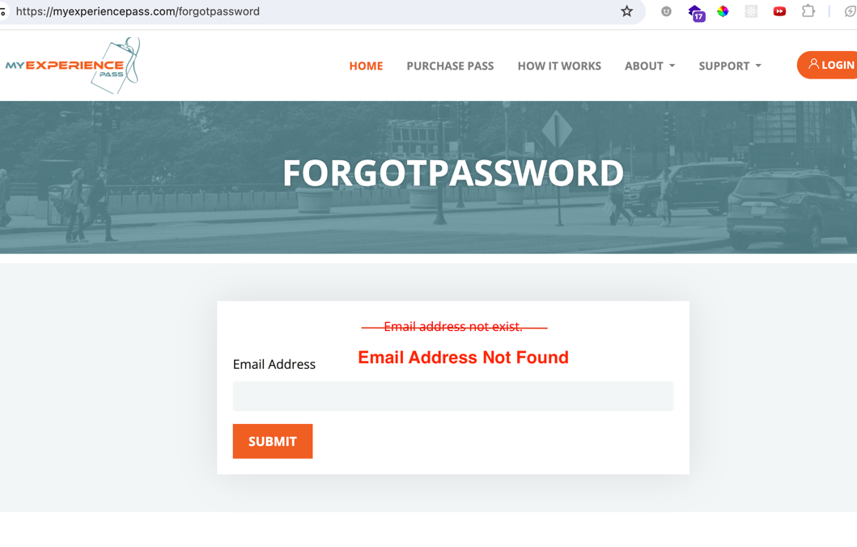

1. Please change the contact email on the welcome/forgot password email to [myexperiencepass@gmail.com](mailto:myexperiencepass@gmail.com) instead of [support@experiencenxt.com](mailto:support@experiencenxt.com). We no longer have that email.

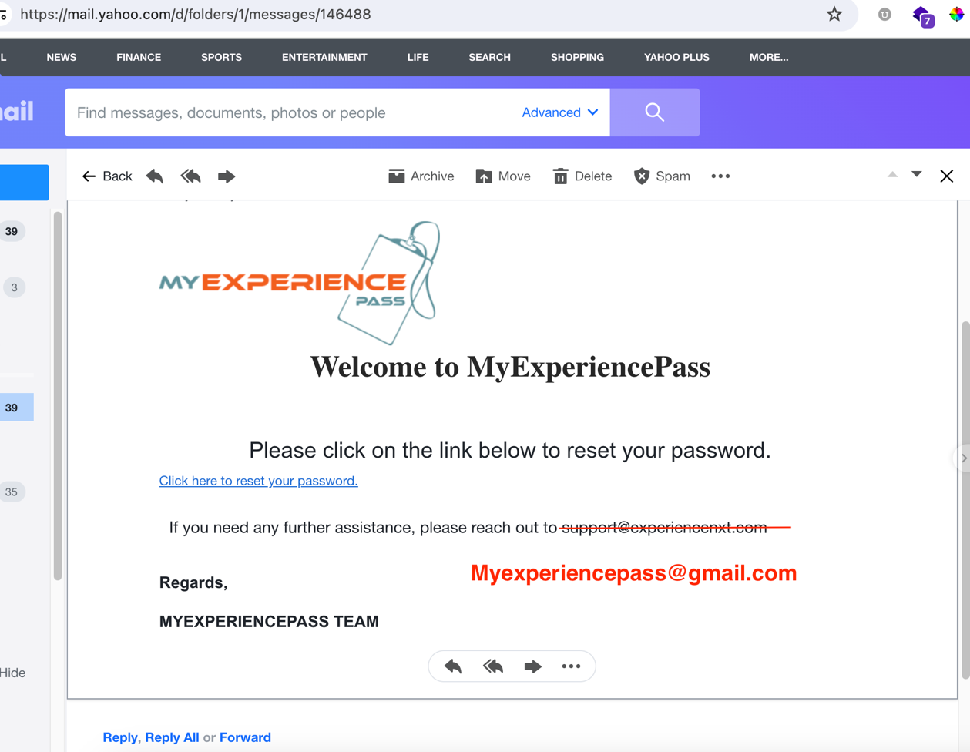

1. When someone contacts us and they click submit, it says congratulation. Please remove this word and move the message below upwards in its place and enlarge the message.

